OpenEMIS Concept Note – EGRA
Measuring Early Grade Reading Assessments using an Open Education Management Information System (OpenEMIS)

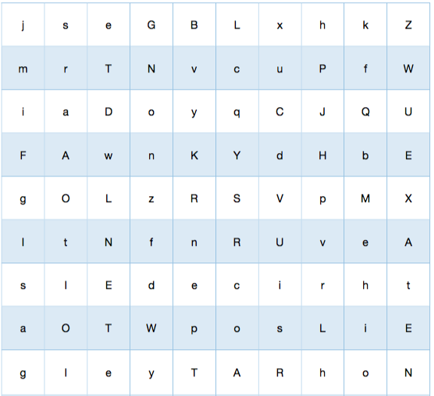

OpenEMIS EGRA

Executive Summary

OpenEMIS EGRA is a free mobile application that can be used by teachers and parents to assess the reading ability of early grade students. EGRA stands for Early Grade Reading Assessment which is an internationally recognized standard for assessing early grade reading. OpenEMIS EGRA uses the standard assessment tests such as identifying and reading letters, words and sentences.

Why Conduct Early Grade Reading Assessments?

Every child is unique and so is their learning style. It has become evident that in order to promote a child’s education and growth, critical information needs to be gathered on their work and performance. EGRA helps in identifying key skills and areas of instruction that need to be improved. It evaluates outcomes of programs designed to improve literacy, and informs the education sector on strategic planning, resource allocation, and budgeting.

Approach/Solution

OpenEMIS EGRA facilitates the way Early Grade Reading Assessments (EGRA) are administered and allows for the data to seamlessly be associate with each student’s administrative data records.

Using OpenEMIS EGRA will:
- Provide a fun and intuitive tool for EGRA
- Allow for multiple sources to assess the same student and compare results
- Develop home testing / exercise curriculum for parents to work with students and have the results be explored by the teacher
- Insights into the students learning style both at home and at school
- Generate reports on a particular student's learning style based on results
- Seamless integration with students’ administrative records.

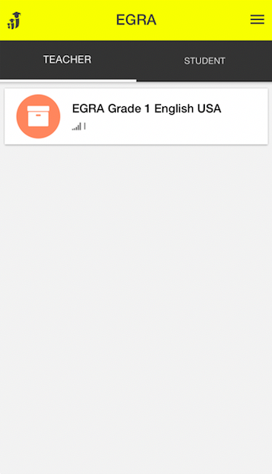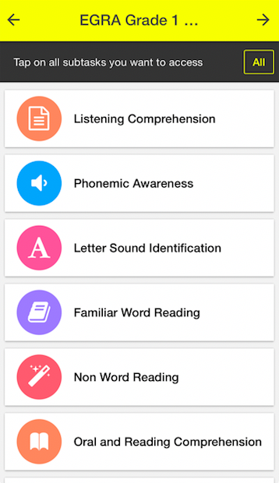

Monitoring and Evaluation

OpenEMIS EGRA supports the timely delivery of assessment results, addressing the current challenges:
- It takes roughly 10 months to prepare, train, collect, and use data results for the ultimate purpose of better policy and improving the quality of education for early grade learners.
- It measures a sample population of students within a respective country. It certainly fulfills its purpose in capturing the broader picture of literacy development but it does not target every student, of whom there may be unique learners or even students with special needs.

Sustainability

The mobile app would enhance existing applications, like Tangerine, by making it more user-friendly, facilitating the processes of data entry, and bypassing the need for capacity building. Without modifying any of its current functionalities (e.g. offline assessments), OpenEMIS EGRA considerably reduces the amount of time it currently takes to train assessors; even allow for any teacher to begin using without training. Teachers will be equipped to assess their own students in literacy development in their respective language(s), and apply the appropriate intervention methods in their classrooms.

References

Significant research has been conducted in the past few years on the best approach to assessing quality of education and learning. Our project draws from the research conducted for the creation of the USAID EGRA Toolkit as well as research conducted by the Center for Global Education Monitoring and Center for international Education.

https://globalreadingnetwork.net/resources/early-grade-reading-assessment-egra-toolkit-second-edition
https://www.openemis.org/products/egra
https://www.openemis.org/files/datasheets/OpenEMIS_EGRA_Datasheet_en.pdf

