OpenEMIS Concept Note – Equity in Education
Tracking and Monitoring Equity in Education Data
using an Open Education Management Information System (OpenEMIS)

March, 2018

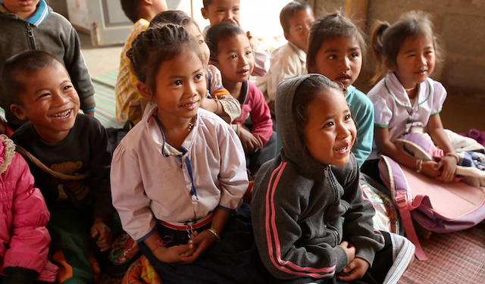

Title
Tracking and Monitoring Equity in Education Data using an OpenEMIS

OpenEMIS Initiative
The OpenEMIS Initiative aims to deploy a high-quality Education Management Information System (EMIS) designed to collect and report data on schools, students, teachers, and staff. The system was conceived by UNESCO to be a royalty-free system that can be easily customized to meet the specific needs of member countries. The initiative is coordinated by UNESCO with technical support provided by Community Systems Foundation. OpenEMIS is well positioned to support national system strengthening in the country while addressing the monitoring requirements of Sustainable Development Goals. OpenEMIS is deployed as a cloud-based application and is designed to be mobile responsive, allowing for access to smartphones and tablets as well as more traditional laptop and desktop computers. A suite of tools is available to enhance OpenEMIS software, providing solutions for data collection, management, analysis and procurement of resources.

Issue
With the new Sustainable Development Goal 4, the importance of Equity in Education entered into the picture more than ever. The voice from the international community tells that the equity in education ensures the best opportunities for all children to achieve their full potential. Moreover, a fair and inclusive system plays a key role in determining the most powerful levers in making society better. Responding to international education reform, countries are recommended to reduce the cost of school failure and dropouts and make education fairer for marginalized children by providing equitable access to education. This will specifically include issues such as access and equity in early childhood, gender equality in education, reaching out of school children, providing technical and vocational training for the vulnerable people including disabilities, and etc. Besides, the significance of establishing a consolidated monitoring system in order to collect reliable data on Equity in Education is urged.

Approach/Solution
OpenEMIS is an easily customizable and non-commercial software solution that member state countries can modify and update the requirements of education sector autonomously. OpenEMIS Core robust EMIS with data collected from institutions, staff, and students owned and managed by the Ministry of Education. The application allows to capture and track various features of education data such as Early Childhood Development, Disabilities in Schools, Out of School Children, School Meals, Wash in Schools, Education in Emergencies, Technical and Vocational Education and Training, and etc. Users can easily customize the system by configuring the education structure and field options to monitor student data on attendance, achievement, and behavior; staff data by location and level of qualifications; and accommodation of special need students following the national policies. OpenEMIS Integrator, OpenEMIS DataManager, and OpenEMIS Dashboard offer to facilitate information flow between the software and other relevant management tools used for the education policy planning. The applications visualize trends with key education performance indicators as well as link education to the other sectors that policymakers can review comprehensive Equity in Education data in a timely manner.

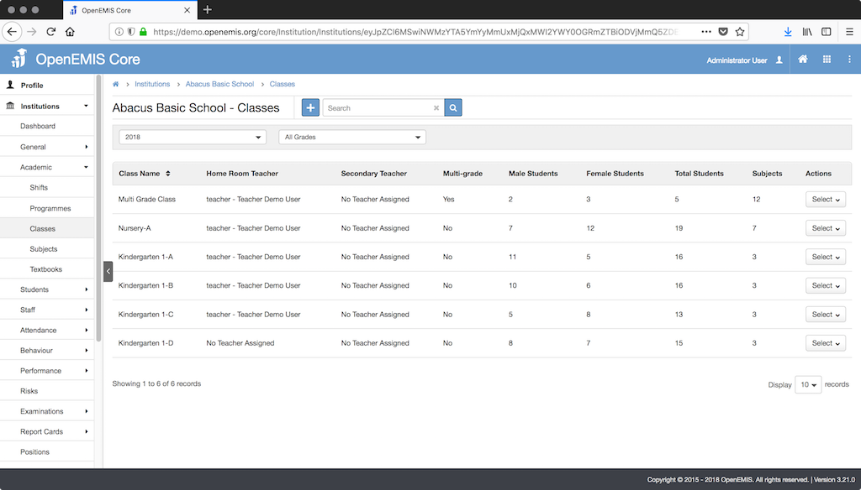

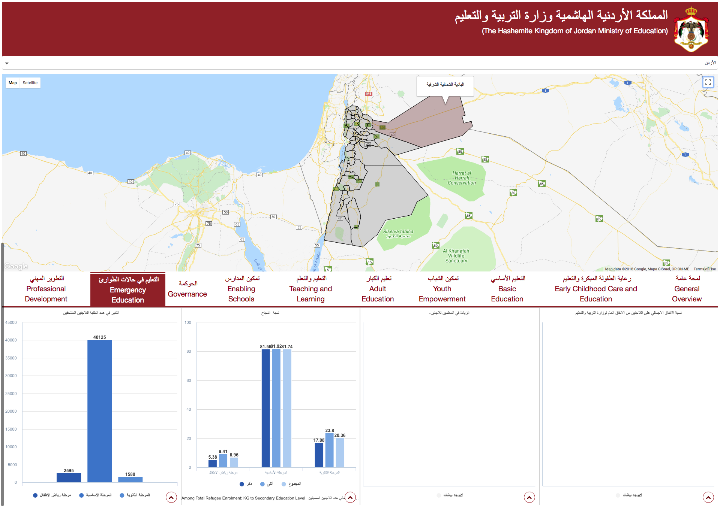

Measurement
Following list of indicators and more can be monitored through OpenEMIS:
- Number of students / staff / institutions
- Percentage of students identified as vulnerable (e.g. disability)
- Number of qualified teaching staff in institutions
- Number of students identified as risk of dropout
- Gross enrolment ratio
- Net enrolment rate
- Number of out-of-school children of primary / secondary age
- Out-of-school rate for children of primary / secondary age
- Survival rate to the last grade of primary / secondary education
- Percentage of children in primary / secondary education who drop out before the last grade
- Percentage of new entrants to primary education without early childhood education
- Number of schools with a functional water point at or near the facility
- Quantity and quality of water
- Percentage of schools with water points accessible to students with disabilities
- Number of functional toilets and urinals for girls, boys, and teachers that meet national standards

Support
To ensure quality project activities for long-term sustainable development, OpenEMIS is providing six types of services (i.e. Policy and Planning Services; Analytical Services; Implementation Services; Support Services; Ad Hoc Services; and Software Development Services) along with Training Services (i.e. Professional; Administrator; Analyst; Trainer; and Advanced Lab) for countries’ capacity building. Moreover, OpenEMIS runs Service Desk from education experts and technicians to support users’ questions and requests as well as online OpenEMIS Support where clients get access to the knowledge base on all applications.

References

Organisation for Economic Co-operation and Development (OECD). Policy Brief – Ten Steps to Equity in Education. January 2008.
http://www.oecd.org/education/school/39989494.pdf

United Nations Educational, Scientific and Cultural Organization (UNESCO). Education Indicators Technical Guidelines 2009 (English, PDF).
https://www.openemis.org/files/resources/Indicator_Technical_guidelines_en.pdf

United Nations Educational, Scientific and Cultural Organization (UNESCO). World Education Forum 2015 – Equity in Education.
https://en.unesco.org/world-education-forum-2015/5-key-themes/equity-education

https://www.openemis.org/support/

