OpenEMIS Concept Note – SDG4
Tracking and Monitoring Sustainable Development Goal 4 Data
using an Open Education Management Information System (OpenEMIS)

February, 2018

Title
Tracking and Monitoring Sustainable Development Goal (SDG) 4 Data using an OpenEMIS

OpenEMIS Initiative
The OpenEMIS Initiative aims to deploy a high-quality Education Management Information System (EMIS) designed to collect and report data on schools, students, teachers, and staff. The system was conceived by UNESCO to be a royalty-free system that can be easily customized to meet the specific needs of member countries. The initiative is coordinated by UNESCO with technical support provided by Community Systems Foundation. OpenEMIS is well positioned to support national system strengthening in the country while addressing the monitoring requirements of Sustainable Development Goals. OpenEMIS is deployed as a cloud-based application and is designed to be mobile responsive, allowing for access to smartphones and tablets as well as more traditional laptop and desktop computers. A suite of tools is available to enhance OpenEMIS software, providing solutions for data collection, management, analysis and procurement of resources.

Issue
On September 25th, 2015, the world leaders of member state countries adopted a set of 17 goals to end poverty, protect the planet and ensure prosperity for all as part of a new Sustainable Development Agenda. The SDG 4, ensuring inclusive and equitable quality education and promoting lifelong learning opportunities for all encompasses 10 targets reaffirming the belief that education is one of the most powerful and proven vehicles for sustainable development. Compared to Millennium Development Goals (MDGs), the mechanics of SDG monitoring focuses on a national level including major thematic communities such as health, education, agriculture, and so forth to mobilize, analyze, and communicate data on the progress towards achieving its objectives. However, studies from international organizations report that many developing countries are not yet prepared or resourced to seize the data revolution in a systematic way, as they need people with relevant skills, investment in the necessary infrastructure and reforms in their institutional and regulatory context.

Approach/Solution
OpenEMIS is an easily customizable and non-commercial software solution that member state countries can modify and update the requirements of education sector autonomously. The OpenEMIS Core robust EMIS with data collected from institutions, staff, and students owned and managed by the Ministry of Education. The application captures and tracks education data on student attendance, achievement, and behavior; tracks staff by location and level of qualifications; and tracks accommodation of special need students following the national policies. The OpenEMIS Integrator, OpenEMIS DataManager, and OpenEMIS Dashboard allow facilitating information flow between the software and other relevant management tools used for the education policy planning. The applications visualize trends with key education performance indicators as well as link education to the other sectors that policymakers can monitor comprehensive SDG data in a timely manner. Examples of OpenEMIS features related to SDG 4 are tracking data for Early Childhood Development, Student Assessment, WASH in Schools, Student Behavior, Staff Qualifications etc.

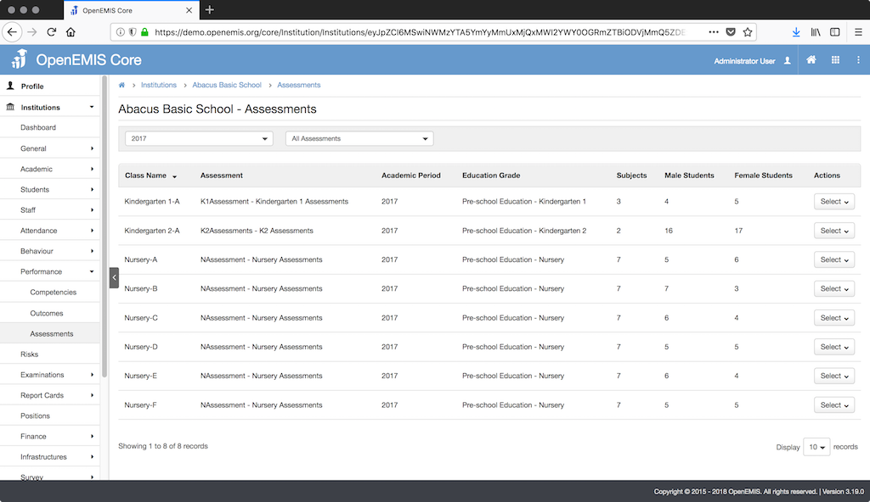

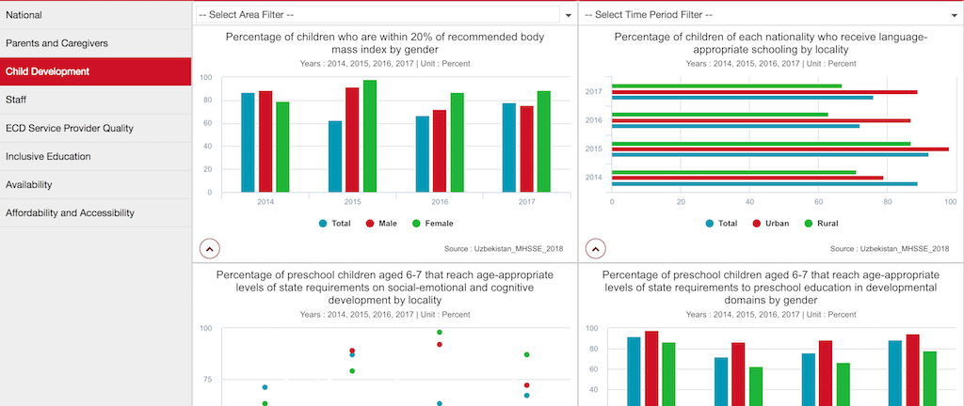

Measurement
Following list of indicators and more can be monitored through OpenEMIS:
- Number of students / staff / institutions
- Percentage of students identified as vulnerable (e.g. disability)
- Number of qualified teaching staff in institutions
- Number of students identified as risk of dropout
- Gross enrolment ratio; Net enrolment rate
- Number of national programmes developed with WFP support (nutrition, school feeding, safety net)
- Quantity of food procured by public institutions receiving WFP support
- Number of schools with a functional water point at or near the facility
- Number of functional toilets and urinals for girls, boys, and teachers that meet national standards
- Number of schools with functional handwashing facilities and soap (or ash) are available for girls and boys in the school

Support
To ensure quality project activities for long-term sustainable development, OpenEMIS is providing six types of services (i.e. Policy and Planning Services; Analytical Services; Implementation Services; Support Services; Ad Hoc Services; and Software Development Services) along with Training Services (i.e. Professional; Administrator; Analyst; Trainer; and Advanced Lab) for countries’ capacity building. Moreover, OpenEMIS runs Service Desk from education experts and technicians to support users’ questions and requests as well as online OpenEMIS Support where clients get access to the knowledge base on all applications.

References
Organisation for Economic Cooperation and Development (OECD). Development Cooperation Report 2017. http://sdg.iisd.org/news/oecd-report-outlines-challenges-and-recommendations-for-sdg-data/

United Nations (UN). Indicators and a Monitoring Framework for the Sustainable Development Goals. https://sustainabledevelopment.un.org/index.php?page=view&type=400&nr=2013&menu=35

United Nations Educational, Scientific and Cultural Organization (UNESCO). Education Indicators Technical Guidelines 2009 (English, PDF).
https://www.openemis.org/files/resources/Indicator_Technical_guidelines_en.pdf

https://www.openemis.org/support/

